Name: Aspeta Divakar

Trainer Name: Harshee Pitroda

Course: Python & ML

Date: 6/6/2022

Code1:

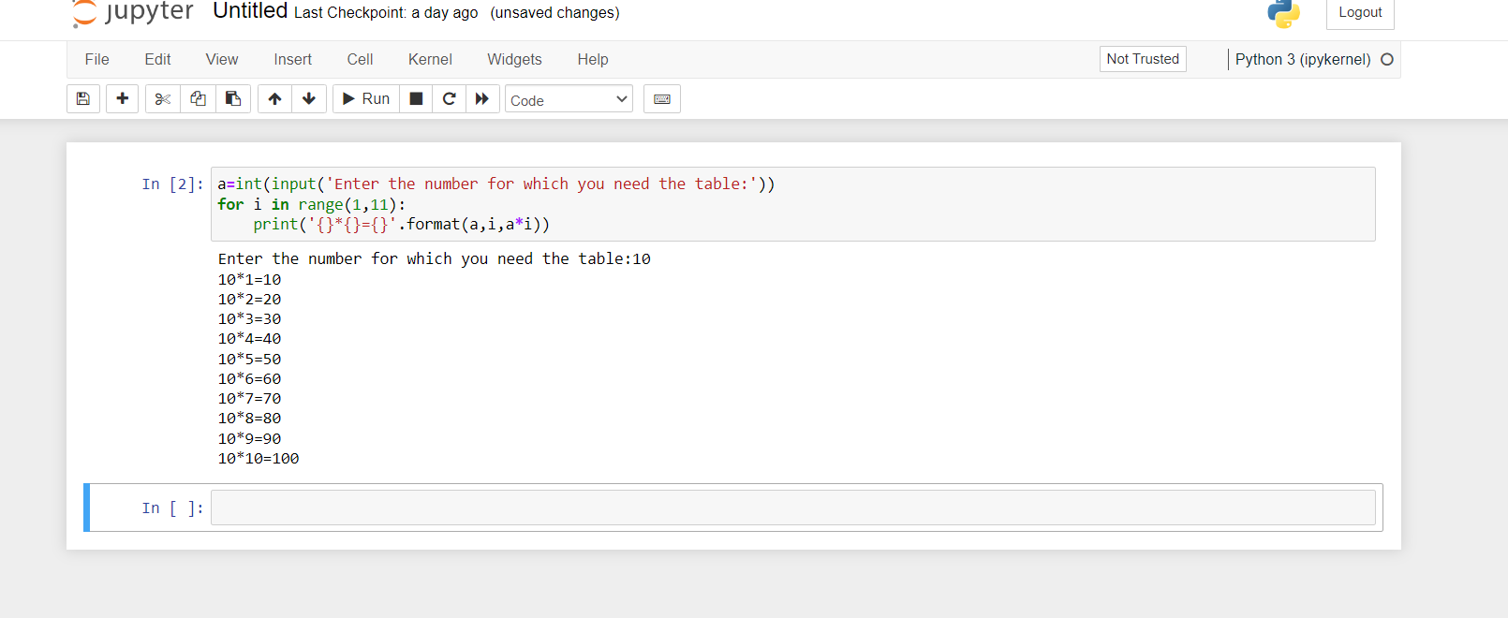

Code2:

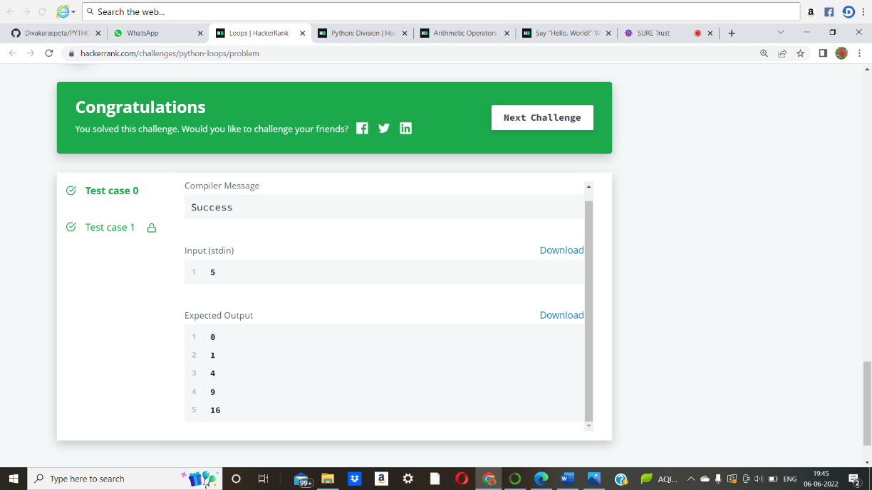

Code3:

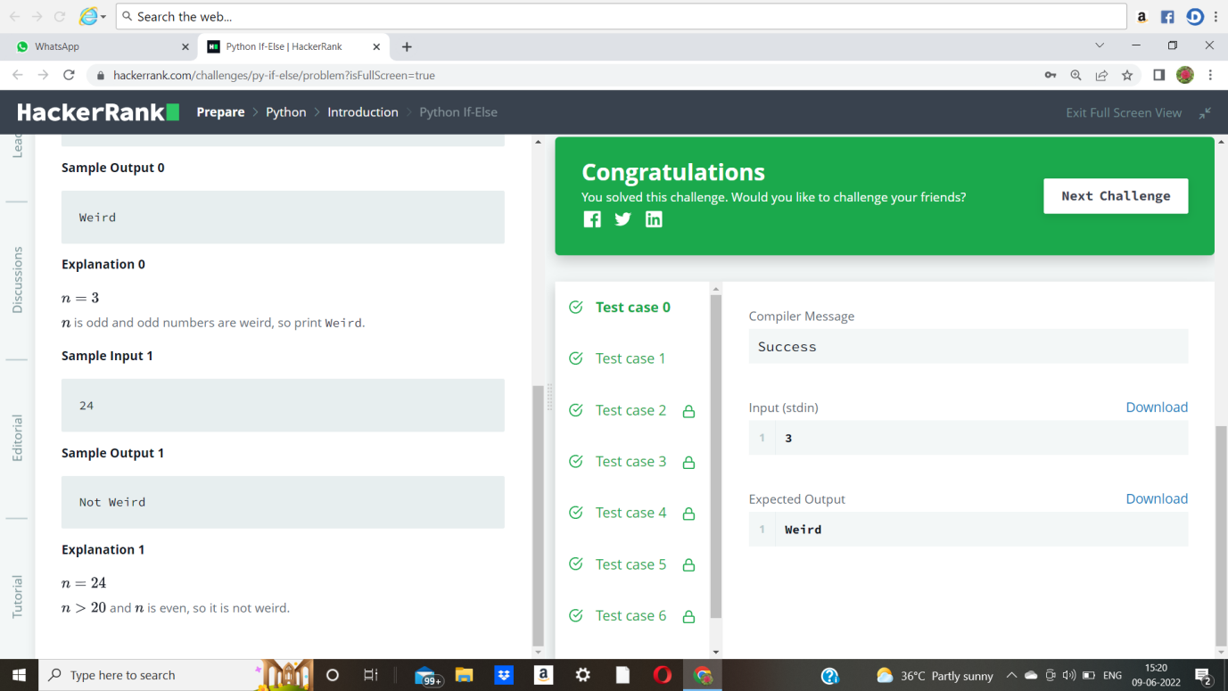

Code4:

